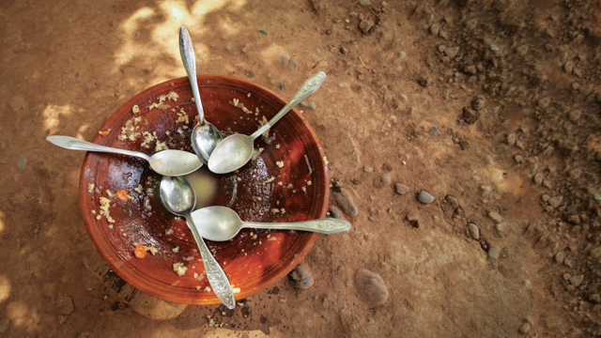

[This Photo](https://unu.edu/publications/articles/taking-hunger-out-of-equation.html) by Unknown Author is licensed under [CC BY-SA-NC](https://creativecommons.org/licenses/by-nc-sa/3.0/)

|  |  |
| --- | --- |
| Can Grocery Delivery Services Reach Food Deserts? | |
| Fruit bowl |  |
| Rice Data Visualization BootcampJanuary 11, 2020Raquel McLellan |  |

|  |  |  |  |
| --- | --- | --- | --- |
|  |  | |  |
| Introduction | | | |
| The Project As part of the class ETL project for the week, I chose to investigate whether grocery delivery service may be a way of reaching areas known as food deserts.  In choosing the sources, I was able to locate the Food Access Research Atlas from the USDA ERS division, which is a main source in tracking the variables that define Food Deserts for people across the US. The next source considered was a well-known grocery delivery service, Instacart to see if their service areas may include these low access/low income areas of concern. While there are other services and potentially even availability from some grocery stores, this is national entity so it seemed that finding information on a broad basis to compare to the USDA ERS data would be more practical.  However, due to the datasets and what they contained, I found that I had to pull additional data sources including the states and their abbreviations from Wikipedia and a third-party US Zipcode source as it contained the County data by City/State combination. | |  | |
| Fruit bowl | |

|  |  |  |  |  |
| --- | --- | --- | --- | --- |
|  | | | | |
|  |  | HEADING Lorem Ipsum is simply dummy text of the printing and typesetting industry. Lorem Ipsum has been the industry's standard dummy text ever since the 1500s, when an unknown printer took a galley of type and scrambled it to make a type specimen book.  Lorem Ipsum is simply dummy text of the printing and typesetting industry. Lorem Ipsum has been the industry's standard dummy text ever since the 1500s, when an unknown printer took a galley of type and scrambled it to make a type specimen book. |  |  |

|  |  |  |
| --- | --- | --- |
|  |  |  |
|  | Lorem Ipsum is simply dummy text of the printing and typesetting industry. |  |
|  |  |  |